Here if client enter correct Url (<https://creditreversalguru.plexif.com/>) then below screen will be displayed

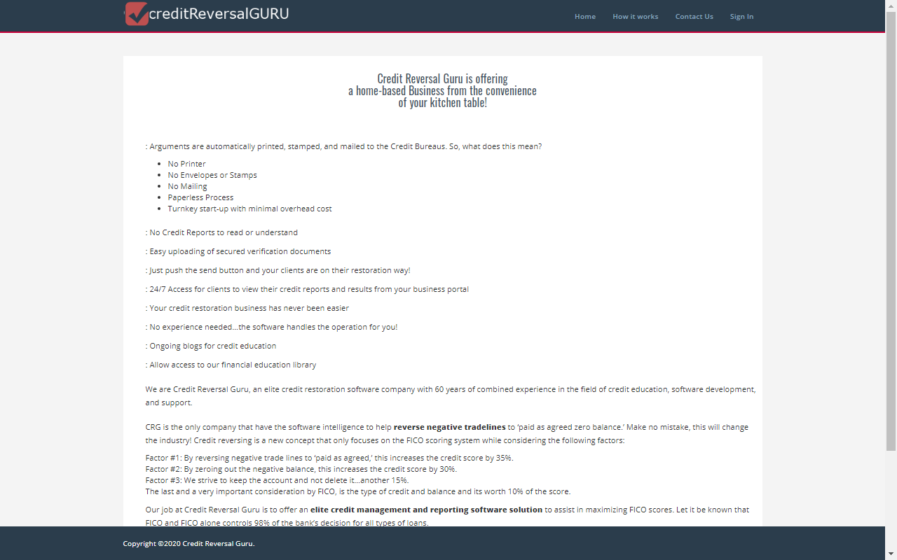

Here in the above screen once agent click Sign in link near header then below sign in screen page will be displayed.

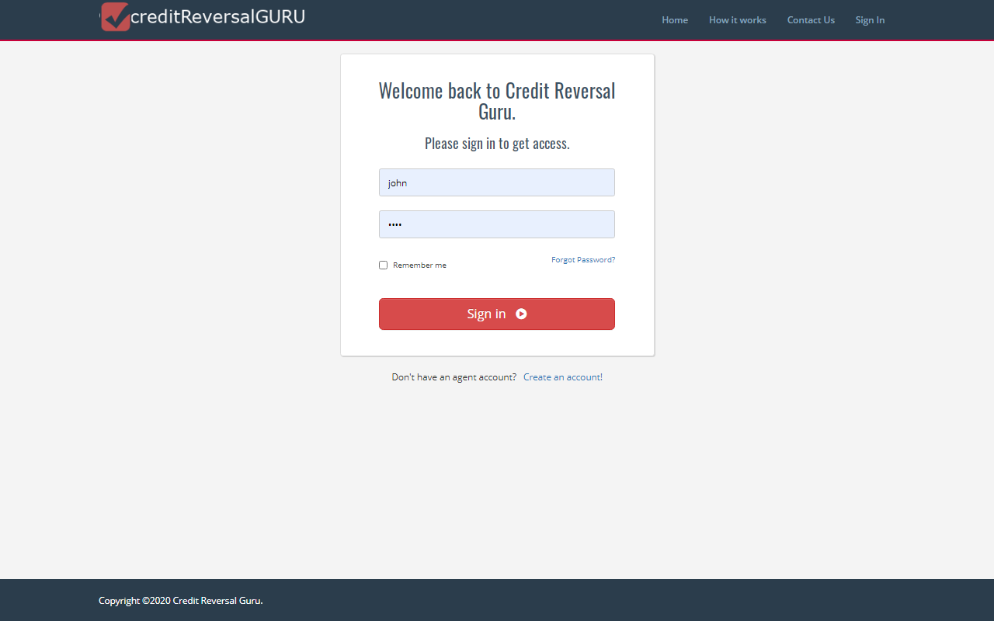

Agent creates new clients using New Client form in Agent Dashboard. When a new client is created, client receives temporary password via email. Once client enter correct username and password and click sign in button then below client dashboard page will be displayed.

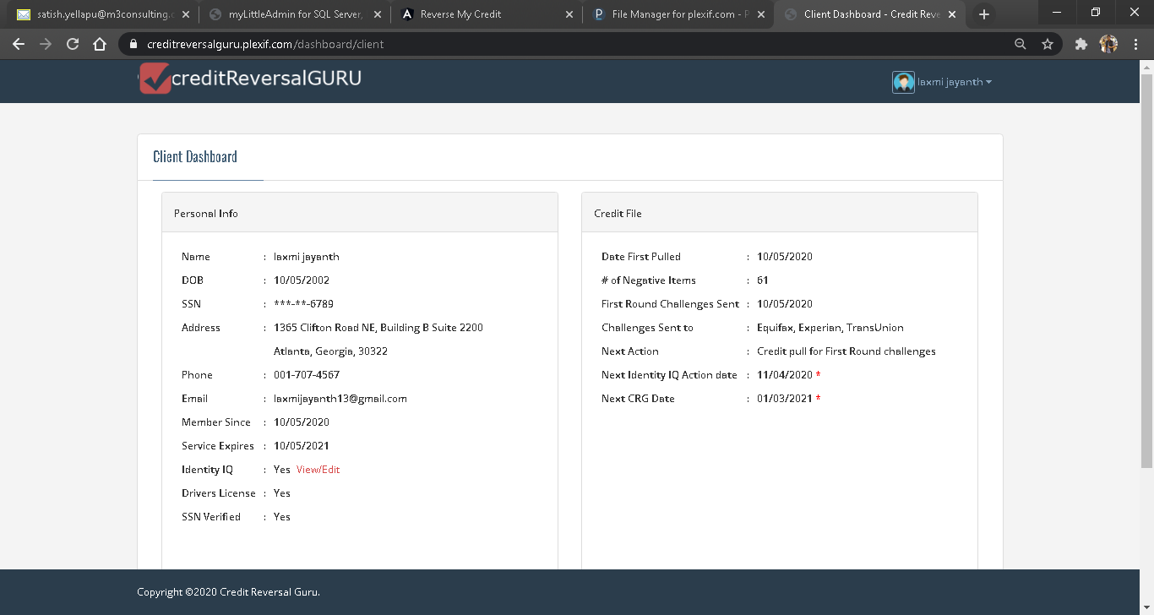

Here in the above client dashboard page if client click view/edit link then below screen will be displayed

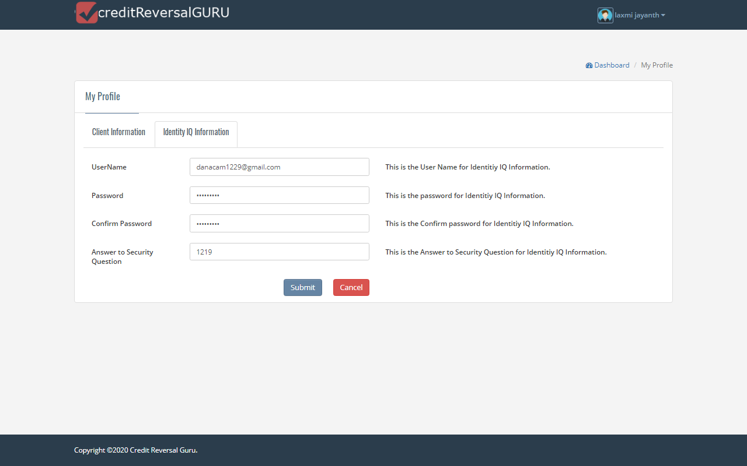

Here in the above screen client can update Identity IQ information and click submit button then client dashboard page will be displayed .



Here if client click View credit report button then client credit items page will be displayed

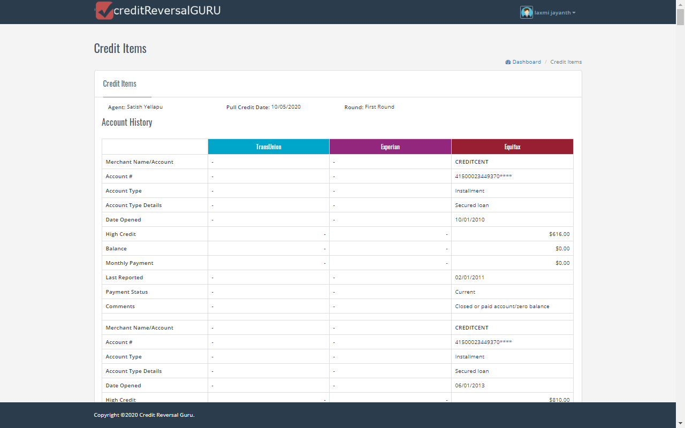

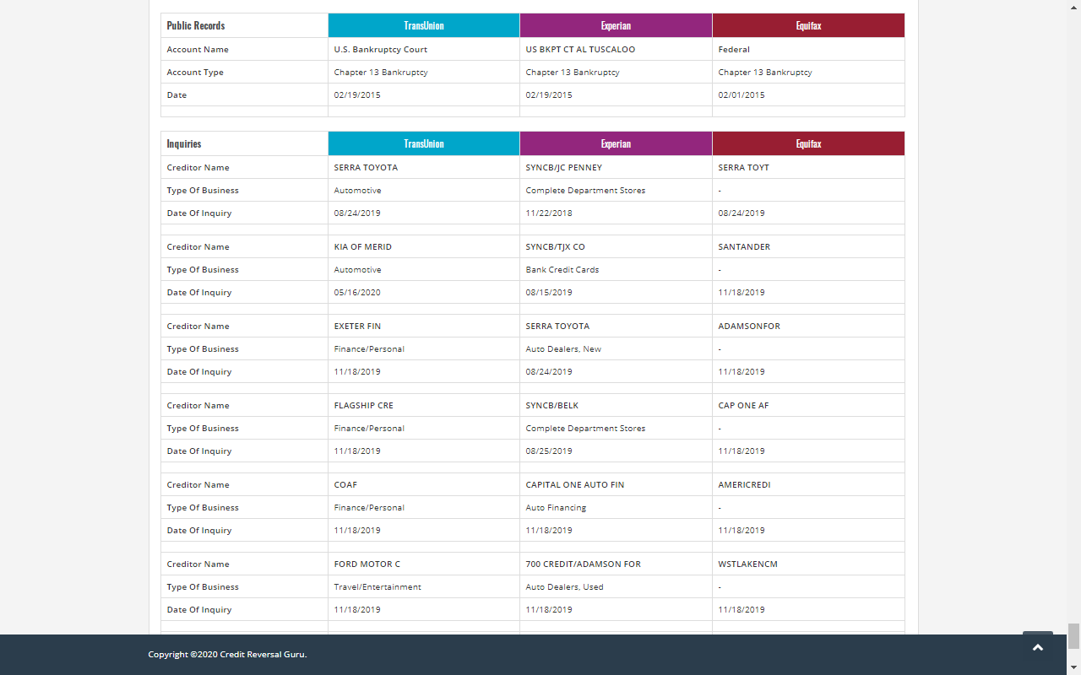

If client click View Challenge Items button in the client dashboard then Challenged item page will be displayed here all rounds challenged items will be displayed that we can see in the below screen

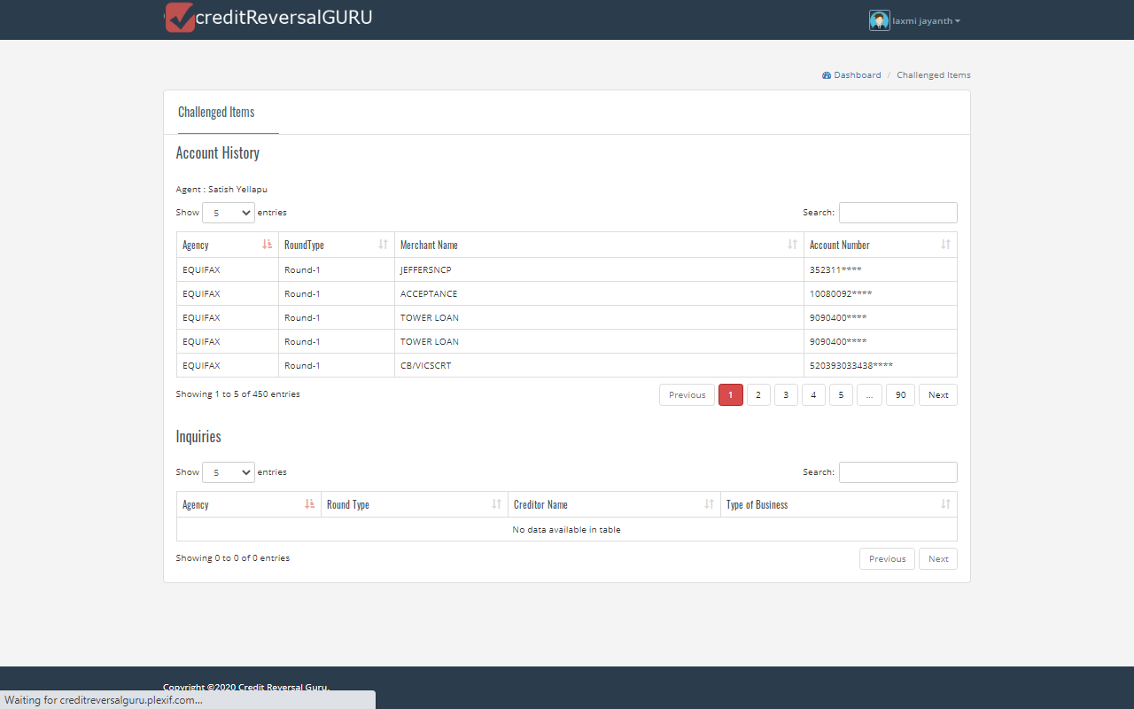

If client click Edit button in client dashboard page then client information page and Identity IQ information will be displayed that we can see in the below screen

